union example
#include <iostream>
#include <cstring>
using namespace std;

union MyUnion {
int num;
char text[20];
};

int main() {
MyUnion u;
strcpy(u.text, "Hello"); // Put a string in the box

cout << "String: " << u.text << endl; // OK
cout << "Integer: " << u.num << endl; // Wrong use!
}

what’s happening in the above code:
- Both num and text share the same memory space.
- When we stored "Hello", those bytes replaced the integer.
- When we print u.num, we’re reading that same memory as an integer — so it prints garbage.

“C++ doesn’t protect you here — it just trusts you.
You can easily make a mistake and not even realize it.”

The program runs but shows random numbers — no warning, no error, just garbage.

Introduction to std::variant

C++17 introduced std::variant, which works like a smart union.
It also stores one of many data types, but it remembers what is currently stored.

Example:
#include <iostream>
#include <variant>
#include <string>
using namespace std;

int main() {
variant<int, string> data; // Can hold either int or string
data = "Hello"; // Store string

cout << get<string>(data) << endl; // Correct access

try {
cout << get<int>(data) << endl; // Wrong access
}
catch (const bad_variant_access& e) {
cout << "Exception caught: " << e.what() << endl;
}
}

what happens in the above code:
- When we assign "Hello",
the variant remembers that the active type is string.
- When we do get<string>(data),
it checks — yes, it’s a string — and prints it.
- When we do get<int>(data),
it checks again — no, it’s not an int —
and throws a runtime exception instead of showing garbage.
So you’ll see output like:
Hello
Exception caught: bad_variant_access

The difference
- Union gives no protection. You can store anything and read anything, even if it doesn’t make sense — C++ won’t stop you.

- Variant protects you. If you try to read the wrong type, it throws an error instead of printing junk.
- So variant is a type-safe version of union.

Summary
- union = old, fast, but dangerous (used in low-level code)
- variant = modern, safe, and smart (used in application-level C++)
- Use variant whenever you want multiple possible types but also safety.

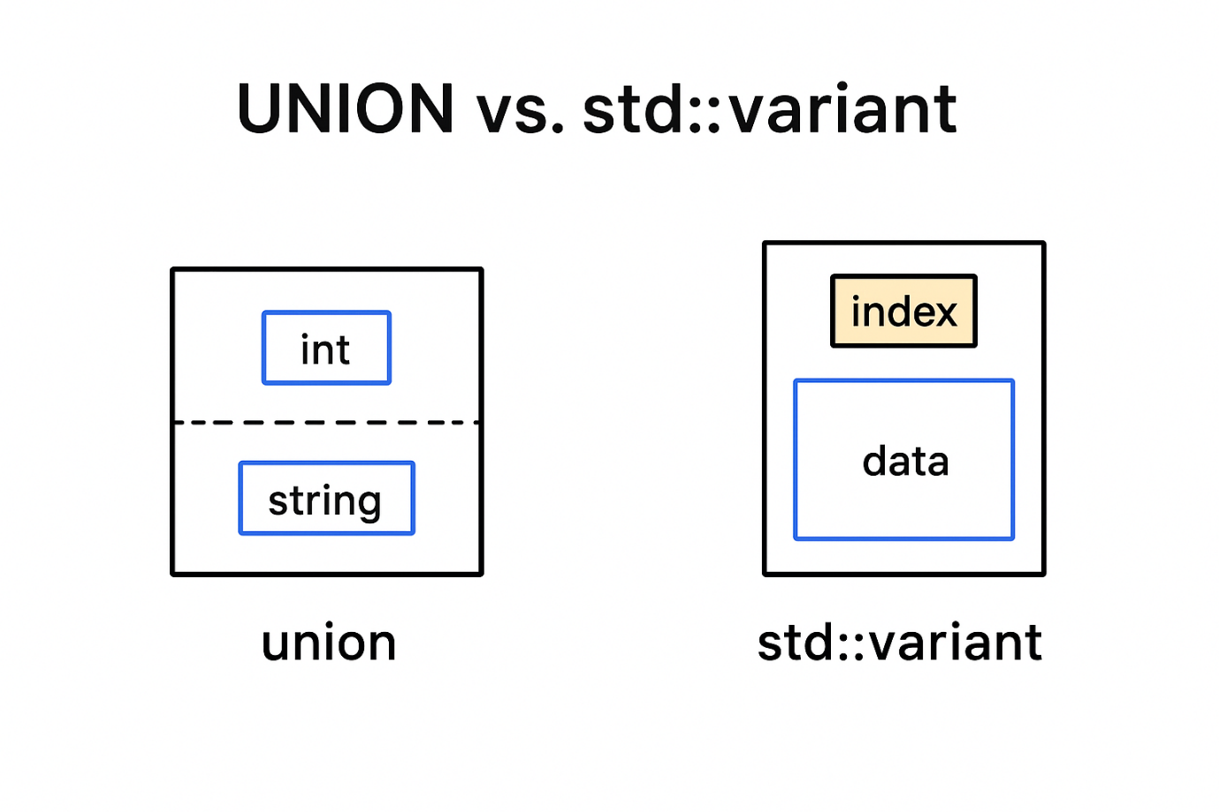

In the above diagram let’s us compare union and std::variant:

In std::variant
- Index → tells which type is currently active in the variant.
For example:
- variant<int, string> v = "Hello";
- cout << v.index(); // prints 1, because 'string' is the 2nd type (0-based)
So index = 0 means it currently holds an int,
and index = 1 means it currently holds a string.
- Data → is the actual value currently stored (the one matching the index).
For example, in the above case, data = "Hello".

In union
There’s no index — the compiler doesn’t track what’s stored.
All members overlap in the same memory space, so you could accidentally read a wrong type:
union U {
int x;
char str[10];
};
U u;
strcpy(u.str, "Hi");
cout << u.x; // no error, but garbage → undefined behavior
So:
- union → Only “data” is stored (no type tracking, unsafe).
- variant → Stores both “index” (type info) and “data” (value), making it type-safe.

Example — std::variant
#include <iostream>
#include <variant>
#include <string>
using namespace std;

int main() {
variant<int, string> data; // can hold int or string

data = 10;
cout << "Index = " << data.index() << endl; // 0 → int
cout << "Value = " << get<int>(data) << endl;

data = "Hello"; // now it holds a string
cout << "\nIndex = " << data.index() << endl; // 1 → string
cout << "Value = " << get<string>(data) << endl;

// Trying to get wrong type
try {
cout << "\nTrying to read as int again..." << endl;
cout << get<int>(data) << endl; // throws exception
}
catch (const bad_variant_access& e) {
cout << "Exception caught: " << e.what() << endl;
}
}
Output:
Index = 0
Value = 10

Index = 1
Value = Hello

Trying to read as int again...
Exception caught: bad_variant_access

Risky Example — union
#include <iostream>
#include <cstring>
using namespace std;

union MyUnion {
int intValue;
char strValue[20];
};

int main() {
MyUnion u;
strcpy(u.strValue, "Hello");
cout << "String value: " << u.strValue << endl;

// Now trying to access intValue (wrong field)
cout << "Int value (after writing string): " << u.intValue << endl; // garbage, undefined
}

Output:
String value: Hello
Int value (after writing string): 1819043144 ← random garbage

